1. Knowledge about ontology

1. Concept of ontology：

Clear specification of conceptualization, explicit formal specification of the shared conceptual model

1. Ontology characteristic:

Conceptualization, Specification, Formalization, Shared

(3) Goal of building an ontology:

Capture relevant domain knowledge, provide a common understanding of the knowledge in the field, identify conceptual terms that are commonly recognized in the field, and use formal means to give a clear definition of these terminology and their interconnections.

(4) Formal representation of ontology

O=(C,R,I,A)

C: Concept collection

R: Relationship collection

I: Instance collection

A: Axiom collection

2. Relational model ontology construction method

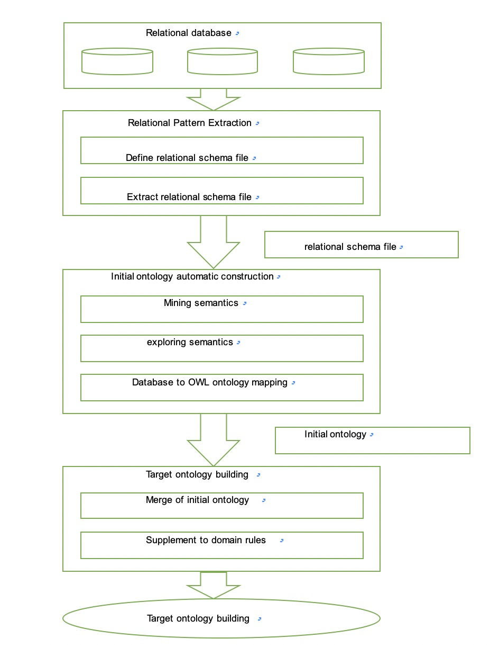

Knowledge base:

Collection of all ontology

(The knowledge base data is stored in the RDF triples mode)

Knowledge graph:

In the knowledge base, connect the ontology with lines, and the lines represent a relationship.

（The **Knowledge Graph** is a [knowledge base](https://link.zhihu.com/?target=https%3A//en.wikipedia.org/wiki/Knowledge_base) used by [Google](https://link.zhihu.com/?target=https%3A//en.wikipedia.org/wiki/Google) to enhance its [search engine](https://link.zhihu.com/?target=https%3A//en.wikipedia.org/wiki/Search_engine)'s search results with [semantic-search](https://link.zhihu.com/?target=https%3A//en.wikipedia.org/wiki/Semantic_search) information gathered from a wide variety of sources.）

